PROJECT PROPOSAL

PROJECT TOPIC:
Cancer Detection Using AI

GROUP MEMBERS:

Aryan Jadhav – 19
Soham Bhosage– 98
Ganraj Kendre – 109
Varnan Dhondage-110()

1) Rationale:

1.1 Motivation:
Cancer is one of the leading problems in the world today. There are about 18.1 million cancer patients in the world today. Cancer can be difficult to detect in the early stages. We can use Artificial Intelligence to find out patterns in the reports of patients in the early stages and help in the prevention of cancerous tumors from growing any further.

1.2 Background:
Artificial intelligence is a computer program or algorithm that uses past data to make future predictions. It teaches itself how to analyse and interpret data, which helps machine learning algorithms pick up on patterns that are not readily discernible to the human eye or brain. As these algorithms are exposed to more new data, their ability to learn and interpret the data improves. Researchers have also used deep learning, a type of machine learning, in cancer imaging applications. Deep learning refers to algorithms that classify information in ways much as the human brain does. Deep learning tools use “artificial neural networks” that mimic how our brain cells take in, process, and react to signals from the rest of our body. Research on AI for cancer imaging: Studies suggest that AI has the potential to improve the speed, accuracy, and reliability with which doctors answer those questions. But what scientists are most excited about is the potential for AI to go beyond what humans can currently do themselves. AI can “see” things that we humans can’t, and can find complex patterns and relationships between very different kinds of data.

1.3 Need of project:
AI can “see” things that we humans can’t, and can find complex patterns and relationships between very different kinds of data. AI can be more reliable when it comes to identifying if a tumor is cancerous or not. The accuracy of AI is reliable enough to be used in real life. This can help radiologists with the identification of tumors. This can also help the doctors, as AI can help to identify some specific features or symptoms of the tumor. This can further help doctors to learn about Cancer.

\

2) Introduction of Project:
As a result, the radiology department has gained prominence in the study of brain tumors using imaging methods. Many studies have looked at the causes of brain tumors, but the results have not been conclusive. FCM helps to increase accuracy. Amato et al. structured PC-assisted recognition using mathematical morphological reconstruction (MMR) for the initial analysis of brain tumors. Test results show the high accuracy of the segmented images while significantly reducing the time of calculation. In classification of neural deep learning systems was proposed for the identification of brain tumors. Discrete wavelet transformation (DWT), excellent extraction method, and main component analysis (PCA) were applied to the classifier here, and performance evaluation was highly acceptable across all performance measurements.

In , a new classifier system was developed for brain tumor detection. The proposed system achieved 92.31% of accuracy. In , a method was suggested for classifying the brain MRI images using an advanced machine learning approach and brain structure analytics. To identify the separated brain regions, this technique provides greater accuracy and to find the ROI of the affected area. Researchers in [proposed a strategy to recognize MR brain tumors using a hybrid approach incorporating DWT transform for feature extraction, a genetic algorithm to reduce the number of features, and to support the classification of brain tumors by vector machine (SVM) . Specific segmentation concepts include region-based segmentation edge-based technique , and thresholding technique for the detection of cancer cells from normal cells. Common classification method is based on the Neural Network Classifier , SVM Classifier , and Decision Classifier . In , a brain tumor detection method was developed using the GMDSWS-MEC model. The result shows high accuracy and less time to detect tumors.

3) Literature Survey:
Artificial intelligence:
Properly from 2000 to 2015
- AI is becoming more and more open-minded.
- In 1950,
Turing [3] presented the famous ‘‘Turing Test’’ which defined
of the concept of ‘‘Machine Intelligence’’
- McCarthy persuaded participants to accept the concept of
‘‘Artificial Intelligence’’
- 1965 It is likewise the beginning of the
first ‘‘Golden age’’ of AI
- AI aims to extend and augment the capacity and efficiency of mankind in tasks of remaking nature and
governing the society through intelligent machines, with the
final goal of realizing a society where people and machines
coexist harmoniously together.

Machine learning:
Nowadays, large amount of data is available everywhere Therefore, it is very important to analyze this data in order to extract some useful information
- Machine learning is an integral part of artificial intelligence
- used in various fields such as bioinformatics, intrusion detection, Information retrieval, game playing, marketing, malware detection, image deconvolution and so on
- It is the most effective method used in the field of data analytics in order to predict something
- These analytical models allow researchers, engineers, data scientists and analysts to produce reliable and valid results and decisions.

4)Problem Definition:

Cancer is the leading cause of death in the world. This disease is characterized by the development of abnormal cells that divide uncontrollably and have the ability to infiltrate and destroy normal body tissue. Cancer often has the ability to spread throughout your body.

Signs and symptoms caused by cancer will vary depending on what part of the body is affected.

Some general signs and symptoms associated with, but not specific to, cancer, include:
- Fatigue.
- Lump or area of thickening that can be felt under the skin.
- Weight changes, including unintended loss or gain.
- Changes in bowel or bladder habits

Cancer is caused by changes (mutations) to the DNA within cells. The DNA inside a cell is packaged into a large number of individual genes, each of which contains a set of instructions telling the cell what functions to perform, as well as how to grow and divide. Errors in the instructions can cause the cell to stop its normal function and may allow a cell to become cancerous. This is how cancer is formed in the body.

5) Proposed Methodology:
The technique used for making this model work is CNN (Convolutional Neural
Network). The different stages by which CNN is applied to the dataset are
1. At first, the required packages are imported.
2. Then the folder where the dataset is stored is imported.
3. Image reading is done after that it is labeled (such as 0 for benign and 1 for malicious) and then the reports are stored in the data frame.
4. Then the size of the image is changed to 224*224 and the shape of the image is.
5. Image normalization is a complete training dataset and a validation dataset was
used for evaluating the model.
6. Then the accuracy of the model is evaluated using the test images.
7. The loss graph and the accuracy graph are plotted.
The entire implementation is done using python 3.8 and is executed on Google
Colaboratory and the model is stored in Google Drive
Results
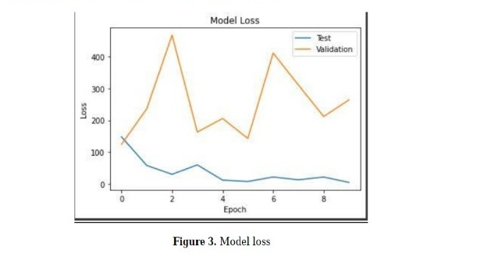When the model is applied to the testing data set for 10 epochs, a validation accuracy of 82.86% is obtained and the validation loss is also less.
As seen in figure 3, when the model is applied to the validation, then a high loss is obtained but once applied to the testing set, the loss gradually decreases with the increasing number of epochs
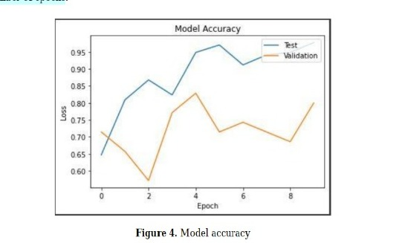
The accuracy of the convolutional neural network model achieved after applying it to the testing set was 97.79%. with a very minimal loss with increasing epochs. The difference in model accuracy can be seen between the validation dataset and the training dataset.
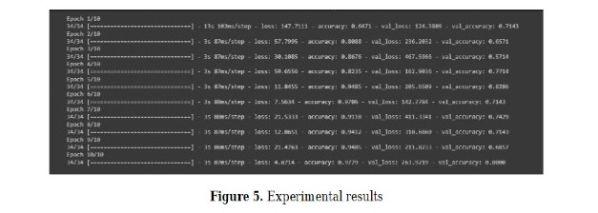

· Block Diagram:
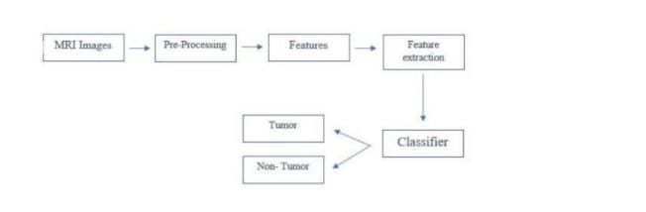
Fig 1.1 Block Diagram.

Block Diagram Description:
We collect the information either in the form of MRI images or MRI reports and then Pre-process them then the AI will detect some features or patterns in the data which is based on the data entered into the AI algorithm in the training sets. These Features will be classified by the classifier as either tumourous or non-tumourous.

6) Software and Hardware Requirement:
• Software requirement
RAM | 8GB
HARD DISK | 40GB
KEY BOARD | Standard windows keyboard
MOUSE | Two or three button mouse
MONITOR | LCD/LED
OPERATING SYSTEM | WINDOWS 11
CODING LANGUAGE | PYTHON
EDITOR | PYCHARM OR VSCODE

7) Action Plan (Schedule of work):

Tasks | Schedule
Requirement Gathering | August 2022
Specification | September 2022
Literature survey | October 2022
Design Analysis | November 2022
Implementation/Coding | December 2022
Testing | February 2023
Deployment/Result Analysis | March 2023
Documentation | April 2023

